# TFL using Kinetics-400

Kinetics-skeleton dataset is used as the source dataset in the TFL. Target child data were not used in the source dataset model training.

Finetuning , Feature Extraction and Propagation Methods were implemented.

The results were compared along with the vanilla models.

For target datasets 4 subsets were used.

1 – full 8 class child dataset

2 – 5 large – unbalanced child subset

3 – 5 large – balanced child subset

4 – 3 small child subset

## Full 8 class dataset

### Vanilla model

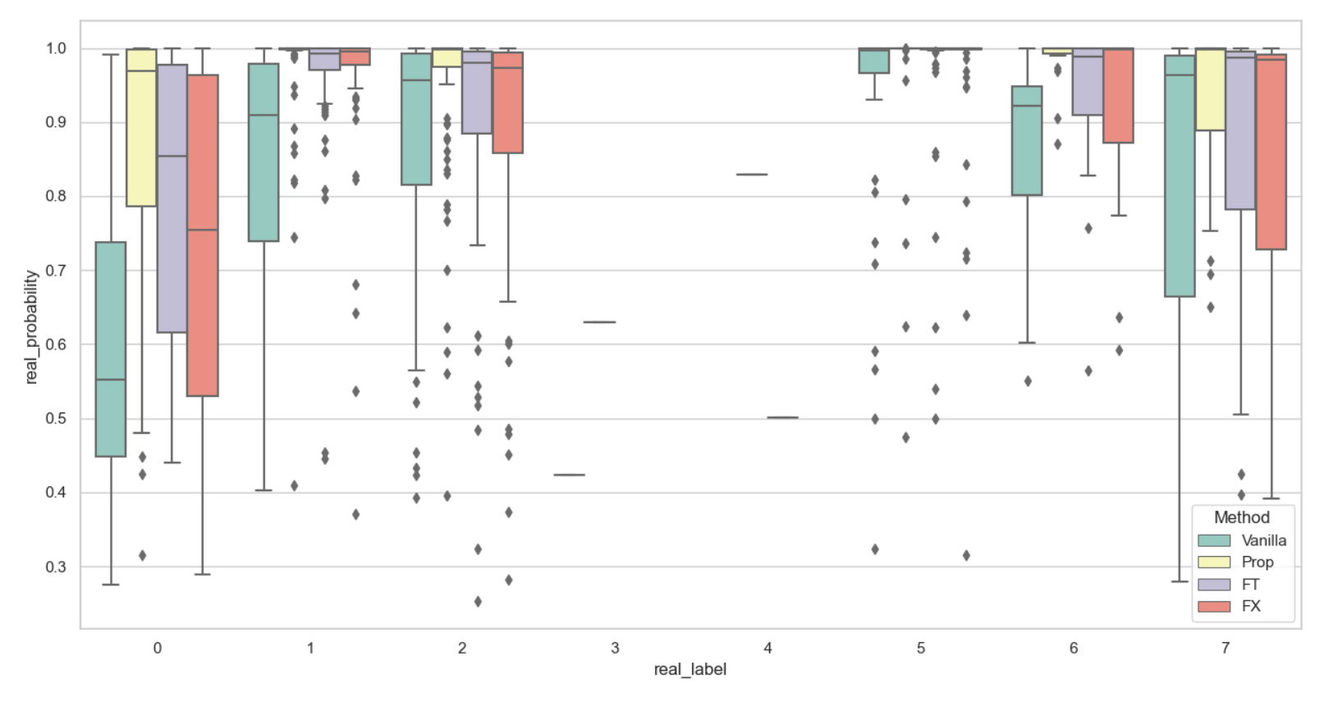classified

Misclassified

All samples

Try vanilla implementation with same FC in the below results.

